Homework 7 – Verilog State Machines (65 points)

1. Use D-type flip-flops and combinational logic to design a synchronous Moore finite-state machine that monitors input “A” and asserts a binary output “B” if the sequence “101” is observed. For example:

If the input data is: A=010101101
The output will be: B=000101001
------------------------------------- time

- Draw the state graph (5 points)
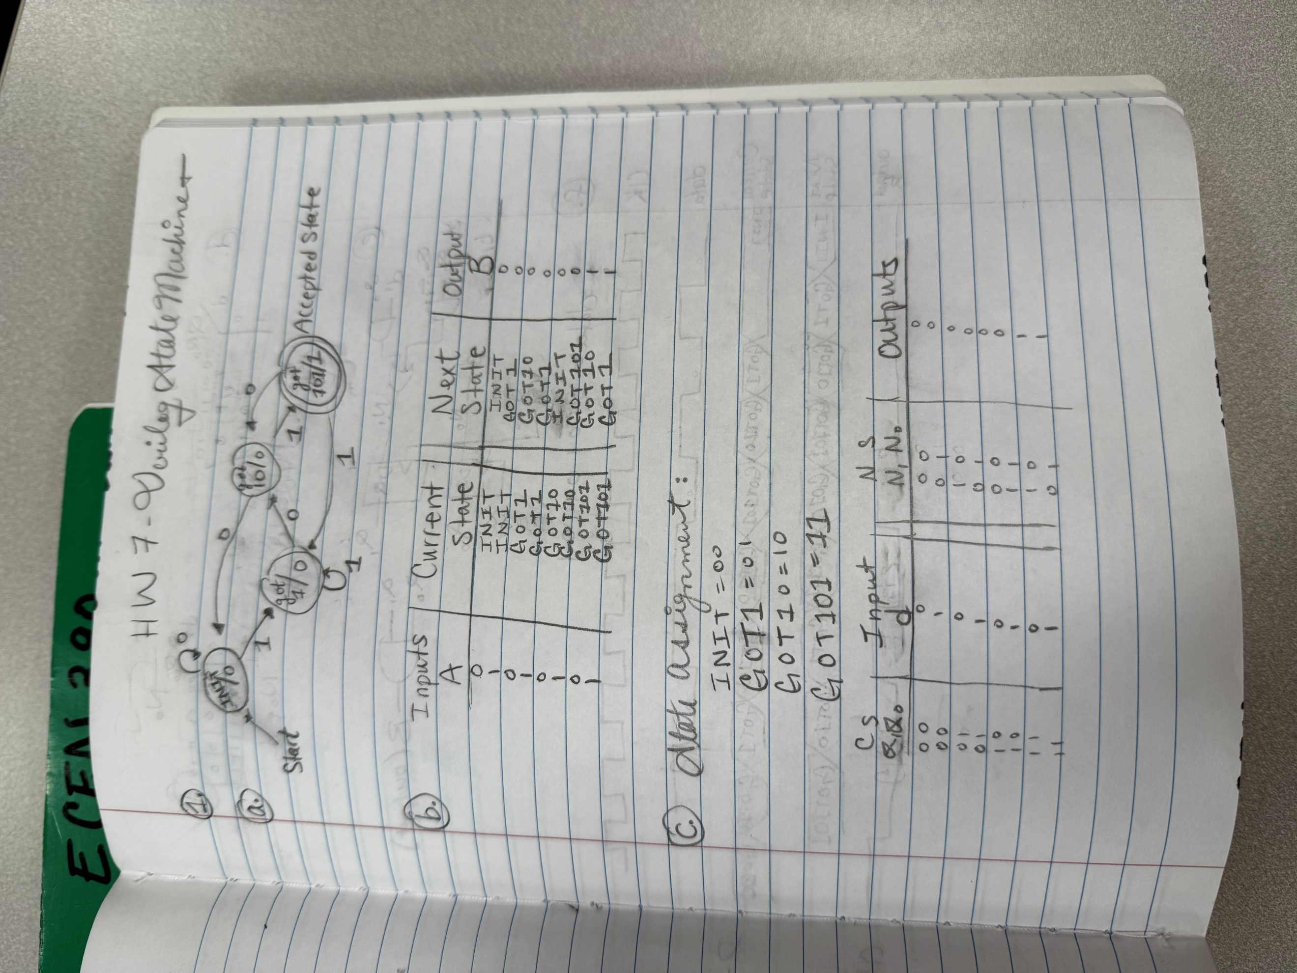
- Create the next state/output table using state names (5 points)


- Make state assignments and substitute numbers for names in the next state table (5 points)

- Determine the minimal circuit realization of the next state logic and output (5 points)
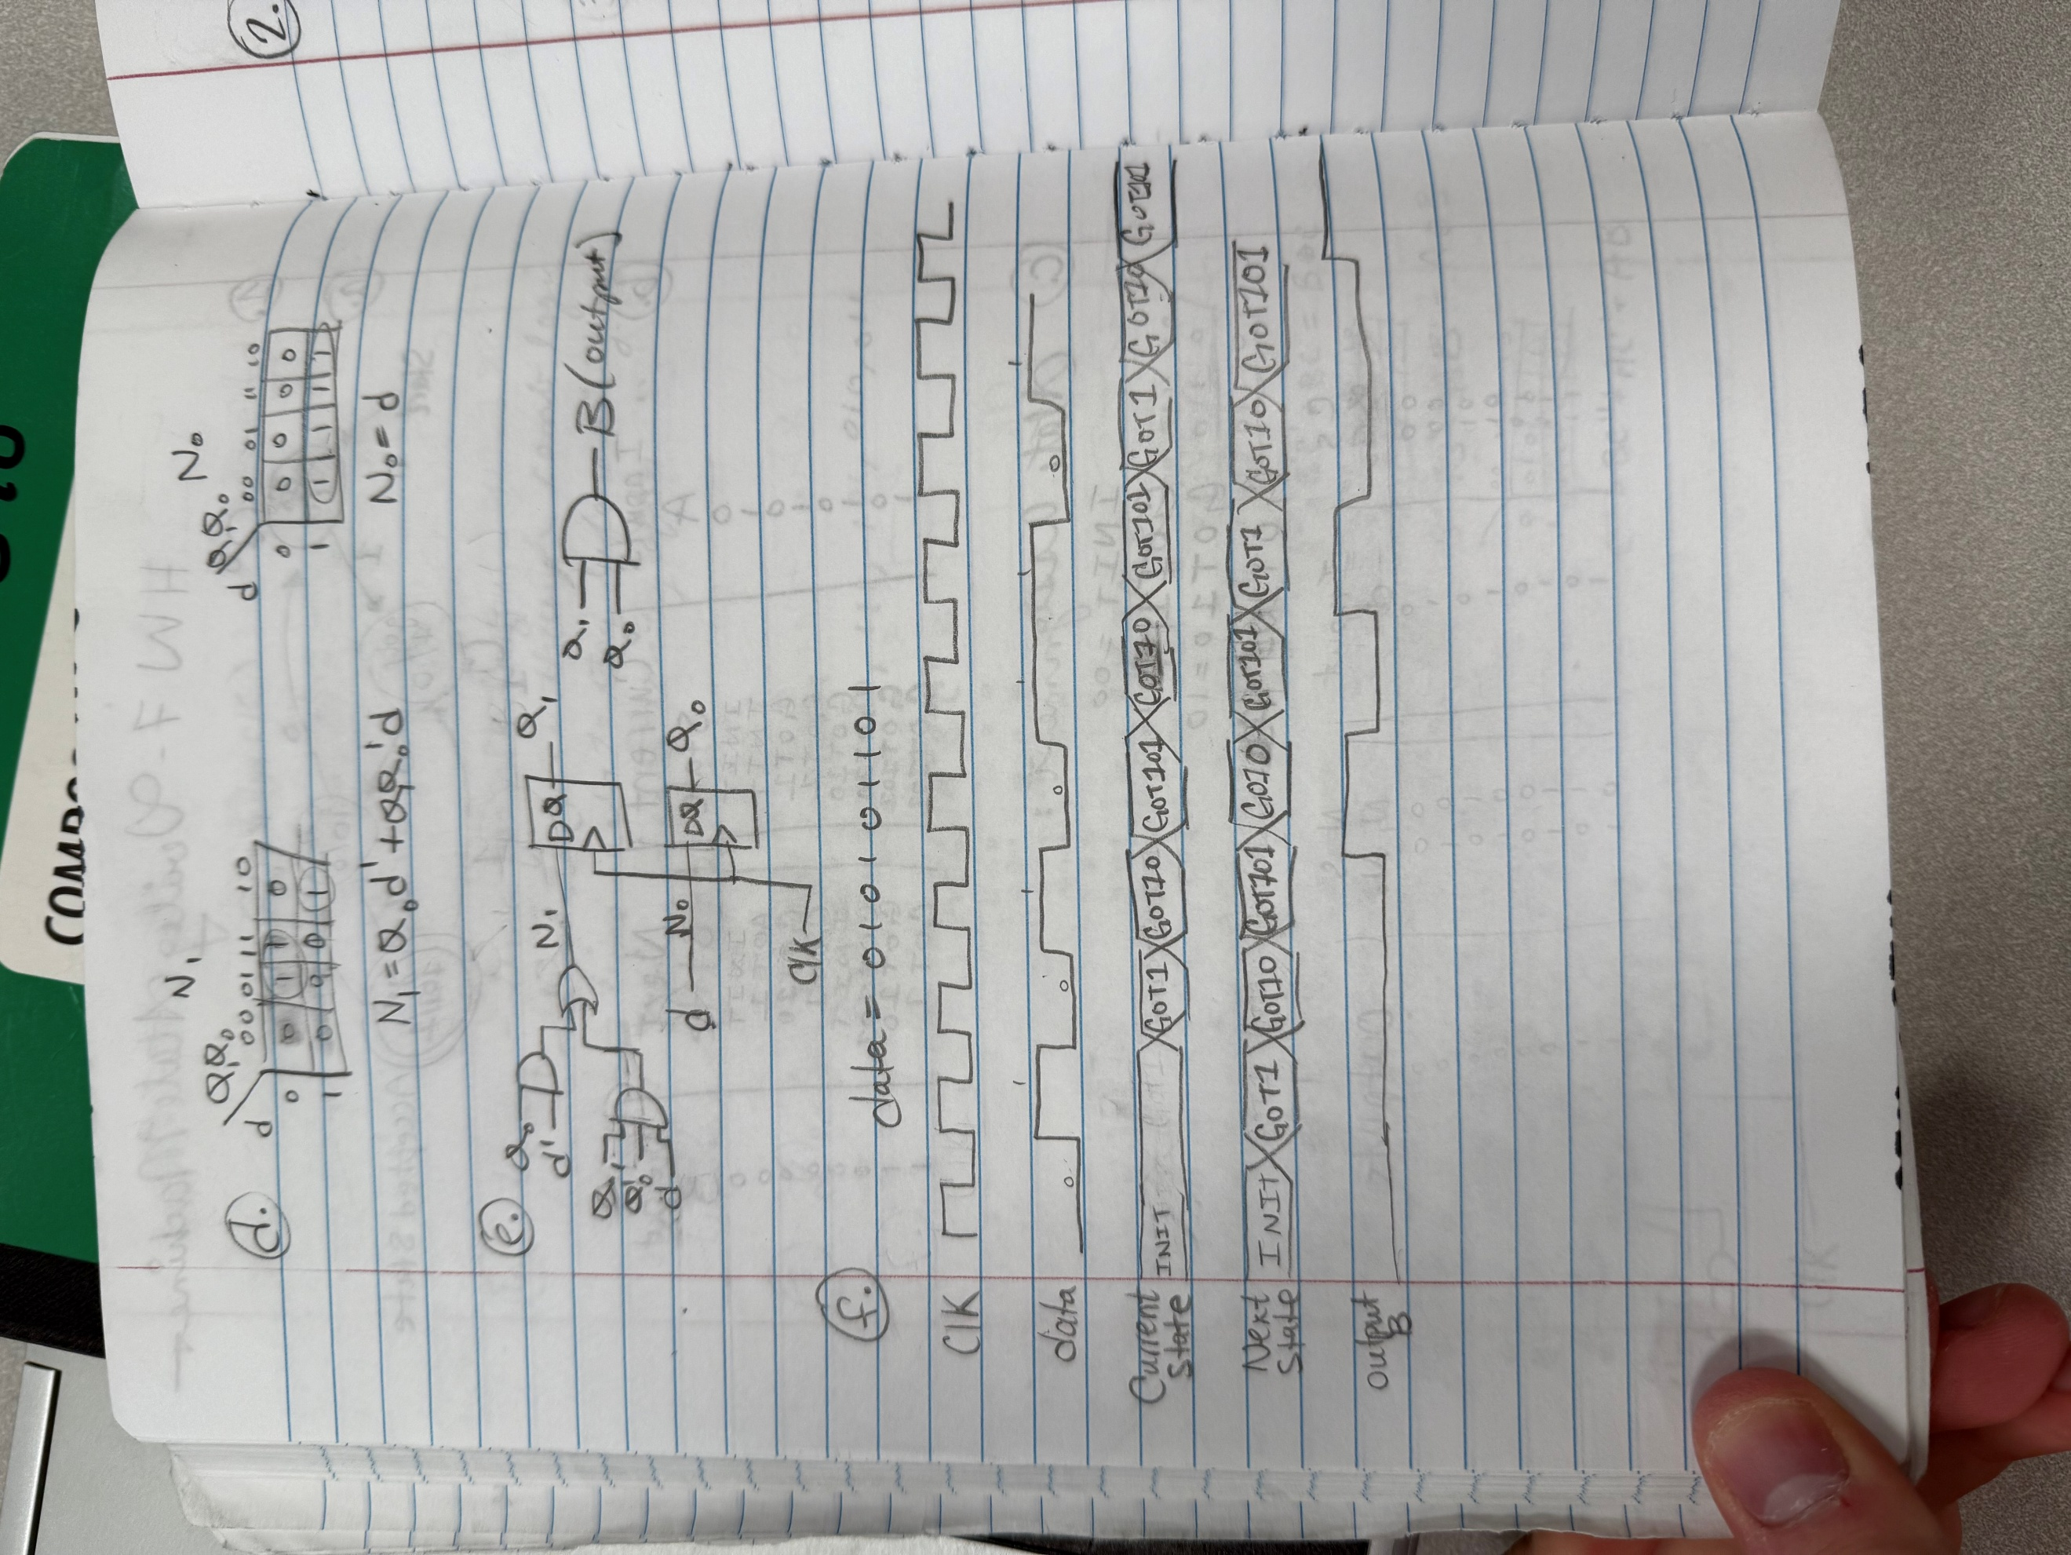
- Draw the circuit (5 points)

- Draw a timing diagram using the input sequence, A = 010101101. Show the input, output, next state, and current state (5 points).


2. Draw the modified State diagram of problem 1 for a Mealy-type State machine (5 points).
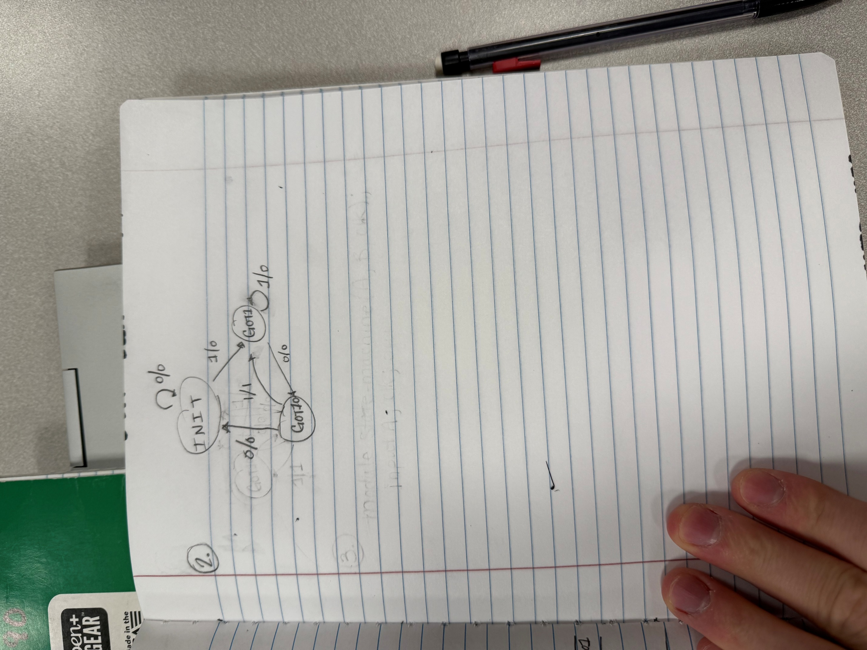

3. Write the Verilog code for the above state machine using Moore-type outputs. When writing the code, please do the following:
- Use parameters for the state names (5 points).
For example:
parameter got1 = 2’b00;
- Use a case statement to determine the next state based on the current state (5 points).
- Place the state flip-flops in their own “always” block (5 points).
- Use a separate case statement for the “found” signal (5 points).
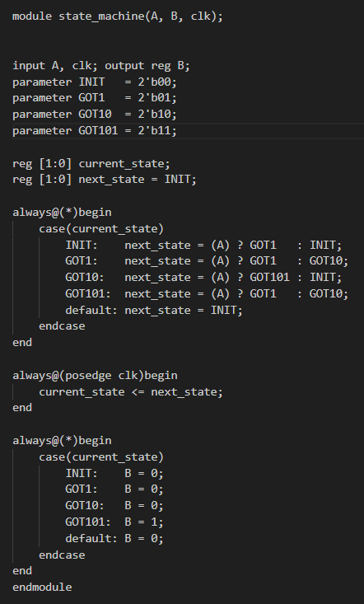

4. Modify the Moore-type output code for the Mealy-type outputs (10 points).

